Khawla
When Khawla arrived at Jemima as a little girl, she could not express her needs with words. Instead, she communicated through her smile, the sparkle in her eyes, and the trust she placed in those who cared for her.
Although Khawla has lived with profound intellectual disabilities throughout her life, she was once much more active than she is today. With the support of her caregivers, she enjoyed walking, moving independently from one place to another, and participating in her daily routine. She especially loved joining activities and being surrounded by the people she knew and trusted.
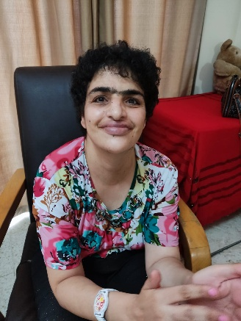
One of the things that made Khawla happiest was wearing wristwatches. She had a favorite watch that she insisted on wearing every day, and it became part of her identity. Everyone at Jemima knew that before leaving for any activity, Khawla would make sure she was wearing her favorite watch.
As the years passed, however, the progression of her disability and the natural effects of aging led to a gradual decline in her physical health. She slowly lost the ability to walk and participate in the activities she once enjoyed. The vibrant daily routines that had once filled her days became increasingly difficult, and she became more dependent on the constant care and dedication of her caregivers, who had become like family to her.
Over the years, Khawla has taught us lessons that cannot be found in books. She has shown us that love is expressed through patience, that dignity is found in the smallest acts of kindness, and that every person deserves to be valued, regardless of their abilities.
In March 2026, Khawla's life changed dramatically. She developed severe pressure ulcers that required emergency surgery and a prolonged hospital stay. What began as treatment for a serious wound soon became a much greater battle. Complications followed, and eventually Khawla could no longer breathe on her own. She was placed on a ventilator, where she remains under constant medical supervision. Her caregivers have spent countless hours at her bedside. They celebrated every small sign of improvement and continued to hope for the next step toward recovery
Sadly, this was not meant to be. On July 17, 2026, Khawla passed away in the hospital in Beit Jala. And on July 18, she was buried in Ramallah, her family's place of residence. The grief and mourning are intense, for her family and the residents and staff of Jemima.

